Chapter 18, Solution 8.

Obtain the Fourier transforms of the signals in Fig. 18.33.

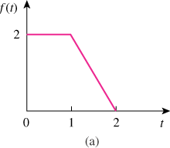

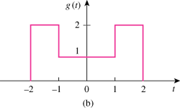

Figure 18.33
For Prob. 18.8.

Solution

(a)

(b) g(t) = 2[ u(t+2) – u(t-2) ] - [ u(t+1) – u(t-1) ]

